### Scriptable Objects(yufen)

**Basic player and enemy data modifications for each scenario:**

You can find prefabs for players and enemies, enemy positions and other damage skills under the corresponding scene name of each scene, and you can modify the corresponding public attribute variables in the Inspector panel of the prefab to adjust to the required data. (You can always ask me if you don’t understand).

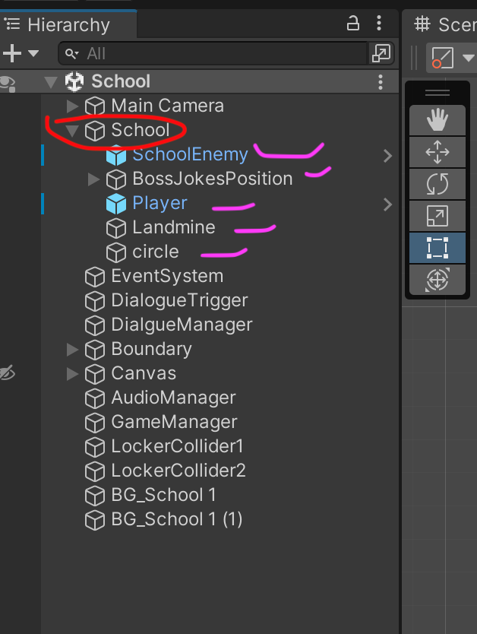

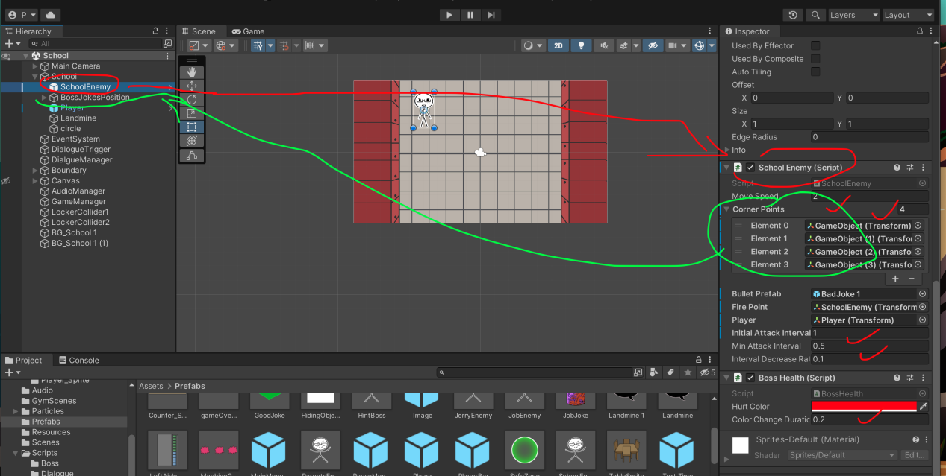

**Modifications of Prefabs:**

You can modify the sprite and size of each prefab in Prefabs (if you are not sure whether it is a prefab on the scene, you can click on the game object you need to modify in the scene, and then open its prefab in the Inspector panel for adjustment)

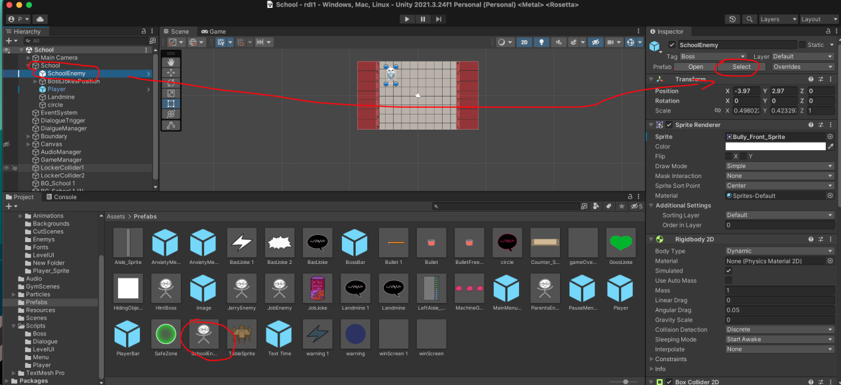

**"DialogueTrigger" object:**

Dialogue is added in "DialogueTrigger"

Drag and drop the background image of the conversation to "Icon"

The text of the dialogue is written in "Line"

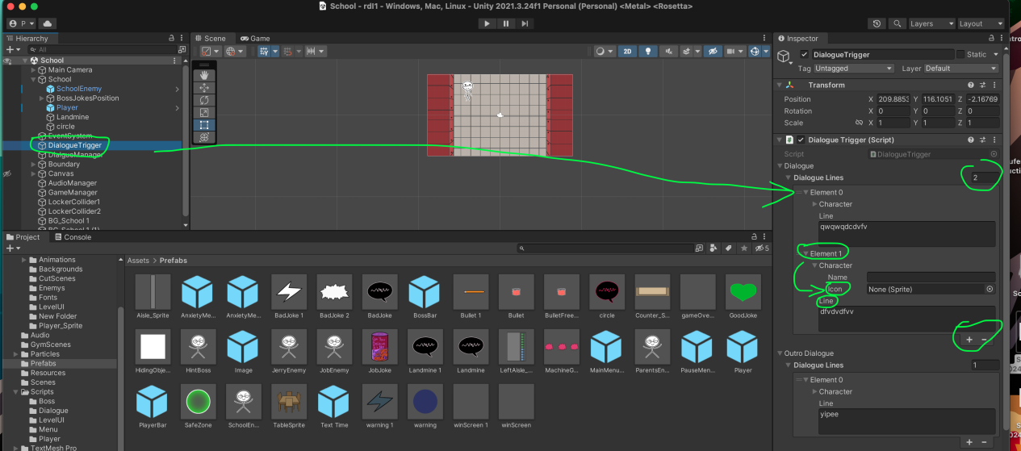

The place where the dialog box of the dialogue is modified

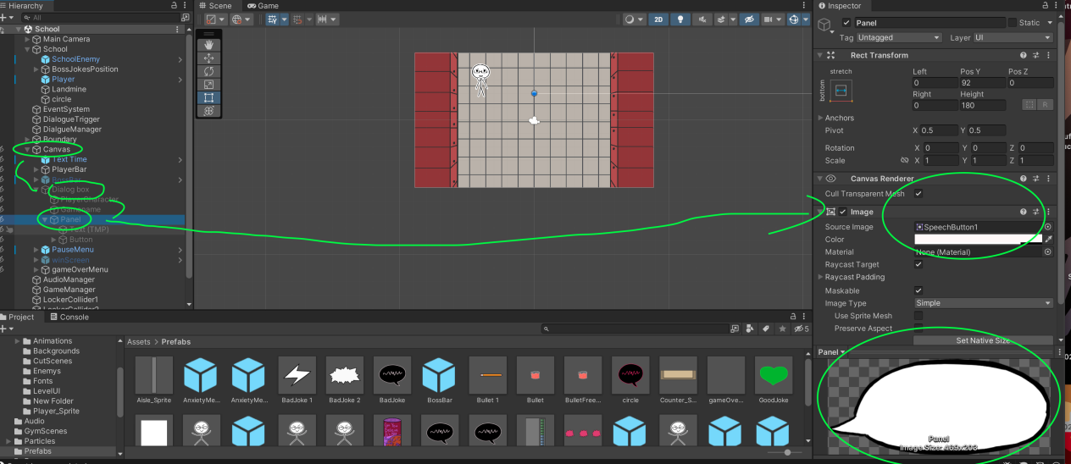

**"GameManager" object:**

The public properties of GameManager can adjust the time of each scene in the Inspector panel (the time of each scene needs to be adjusted) and the generation time and number of healthy prefabs of each scene.

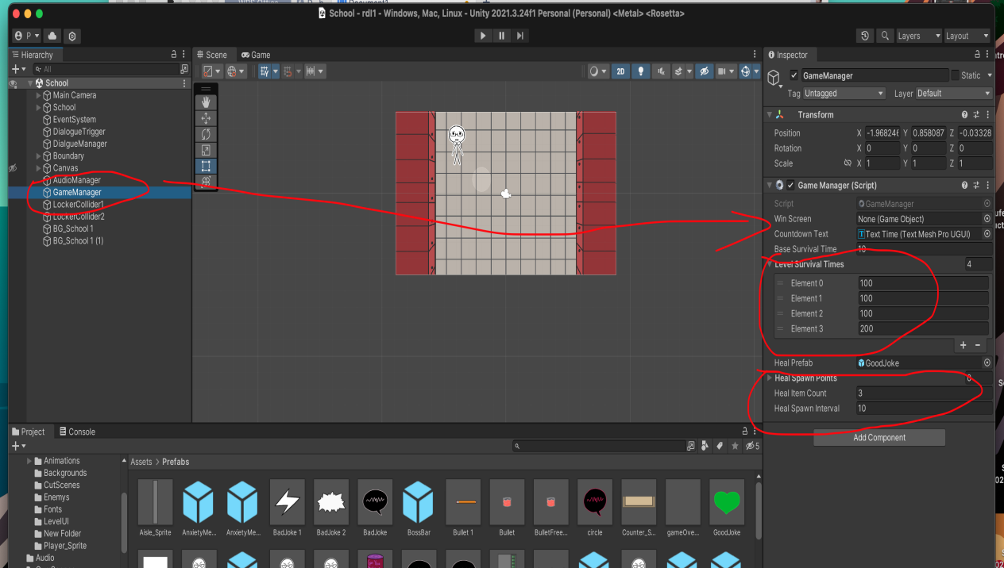

The time of the three stages of the party scene needs to be modified in the script and Update time.

